Design Principles and Patterns
Name: M. Sai Teja Email: saitejamuddapati@gmail.com
Exercise 1: Implementing the Singleton Pattern
Scenario
We need to ensure that a logging utility class in our application has only one instance throughout the application lifecycle to ensure consistent logging.
Java Code
Logger.java
public class Logger {
private static Logger instance;

private Logger() {}

public static Logger getInstance() {
if (instance == null) {
instance = new Logger();
}
return instance;
}

public void log(String message) {
System.out.println("[LOG] " + message);
}
}

SingletonTest.java
public class SingletonTest {
public static void main(String[] args) {
Logger logger1 = Logger.getInstance();
Logger logger2 = Logger.getInstance();

logger1.log("Application started");
logger2.log("User logged in");

if (logger1 == logger2) {
System.out.println("Both variables point to the same Logger instance.");
} else {
System.out.println("Different instances found - Singleton failed!");
}
System.out.println("logger1 hashCode: " + logger1.hashCode());
System.out.println("logger2 hashCode: " + logger2.hashCode());
}
}

Output
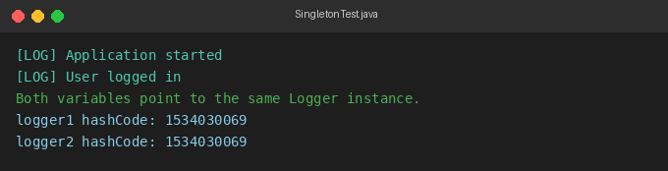
Exercise 2: Implementing the Factory Method Pattern
Scenario
Developing a document management system that needs to create different types of documents (e.g., Word, PDF, Excel). Use the Factory Method Pattern to achieve this.
Java Code
FactoryMethodTest.java
interface Document {
void open();
void save();
}

class WordDocument implements Document {
public void open() {
System.out.println("WordDocument: Opening a Word document.");
}
public void save() {
System.out.println("WordDocument: Saving Word document as .docx");
}
}

class PdfDocument implements Document {
public void open() {
System.out.println("PdfDocument: Opening a PDF document.");
}
public void save() {
System.out.println("PdfDocument: Saving PDF document as .pdf");
}
}

class ExcelDocument implements Document {
public void open() {
System.out.println("ExcelDocument: Opening an Excel document.");
}
public void save() {
System.out.println("ExcelDocument: Saving Excel document as .xlsx");
}
}

abstract class DocumentFactory {
public abstract Document createDocument();
}

class WordDocumentFactory extends DocumentFactory {
public Document createDocument() {
return new WordDocument();
}
}

class PdfDocumentFactory extends DocumentFactory {
public Document createDocument() {
return new PdfDocument();
}
}

class ExcelDocumentFactory extends DocumentFactory {
public Document createDocument() {
return new ExcelDocument();
}
}

public class FactoryMethodTest {
public static void main(String[] args) {
DocumentFactory factory;
Document doc;

System.out.println("Creating Word Document...");
factory = new WordDocumentFactory();
doc = factory.createDocument();
doc.open();
doc.save();

System.out.println("\nCreating PDF Document...");
factory = new PdfDocumentFactory();
doc = factory.createDocument();
doc.open();
doc.save();

System.out.println("\nCreating Excel Document...");
factory = new ExcelDocumentFactory();
doc = factory.createDocument();
doc.open();
doc.save();
}
}

Output
